<https://cloud.google.com/>

Get started for free

Use another account

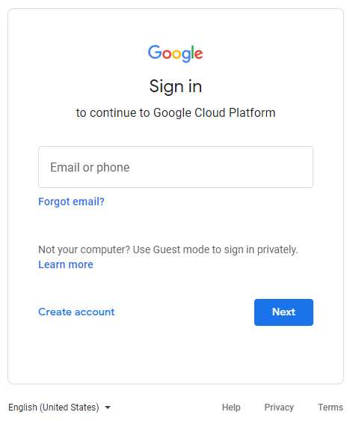

Create account / For myself

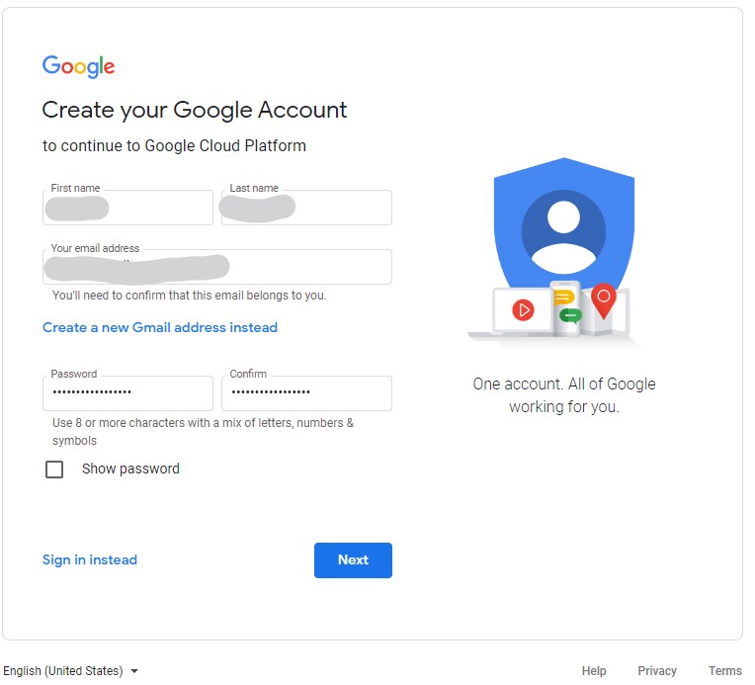

First name / Last name / Email address (not gmail) / Password => Next

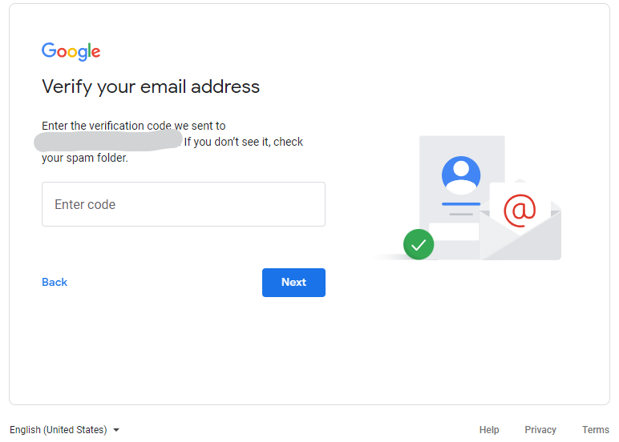

Enter code => Next

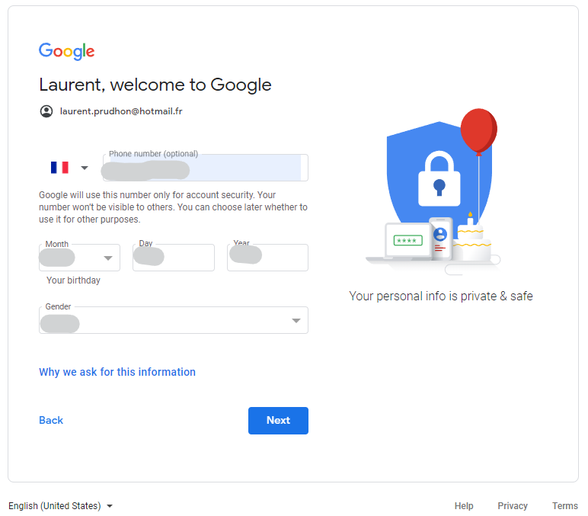

Phone number / Birth date / Gender => Next

Send

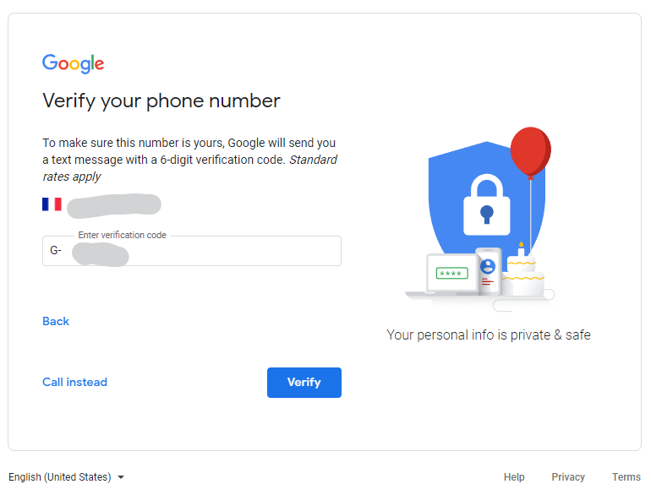

Enter verification code => Verify

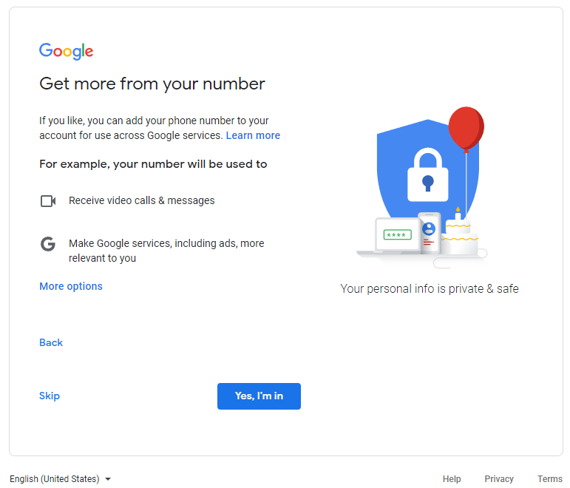

Skip

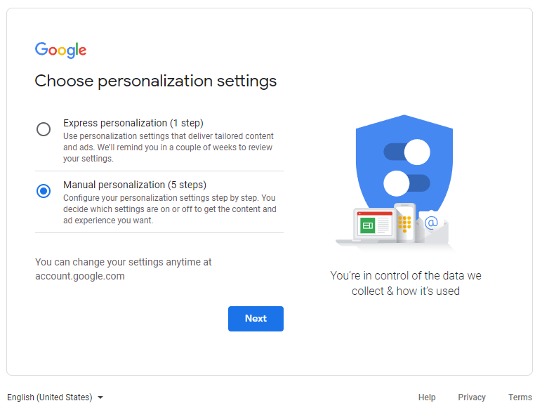

Manual personalization => Next

Choose your personalization settings (you can disable everything) => Confirm

* I agree

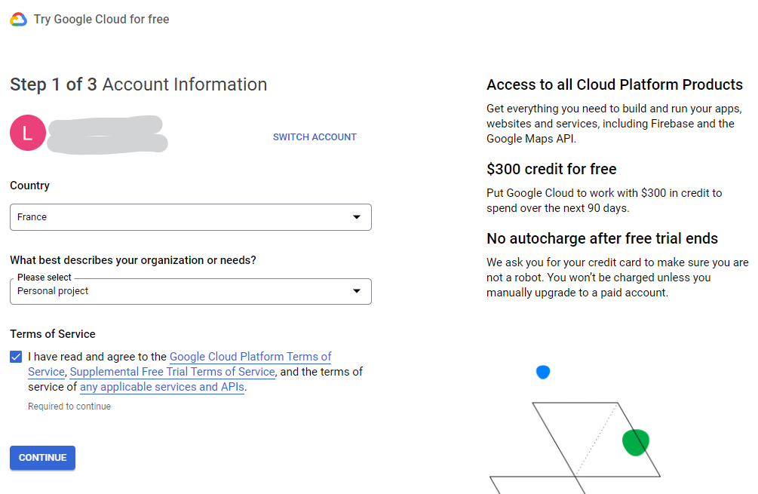

Select Country / Organization or needs / Check terms of service => Continue

* Continue

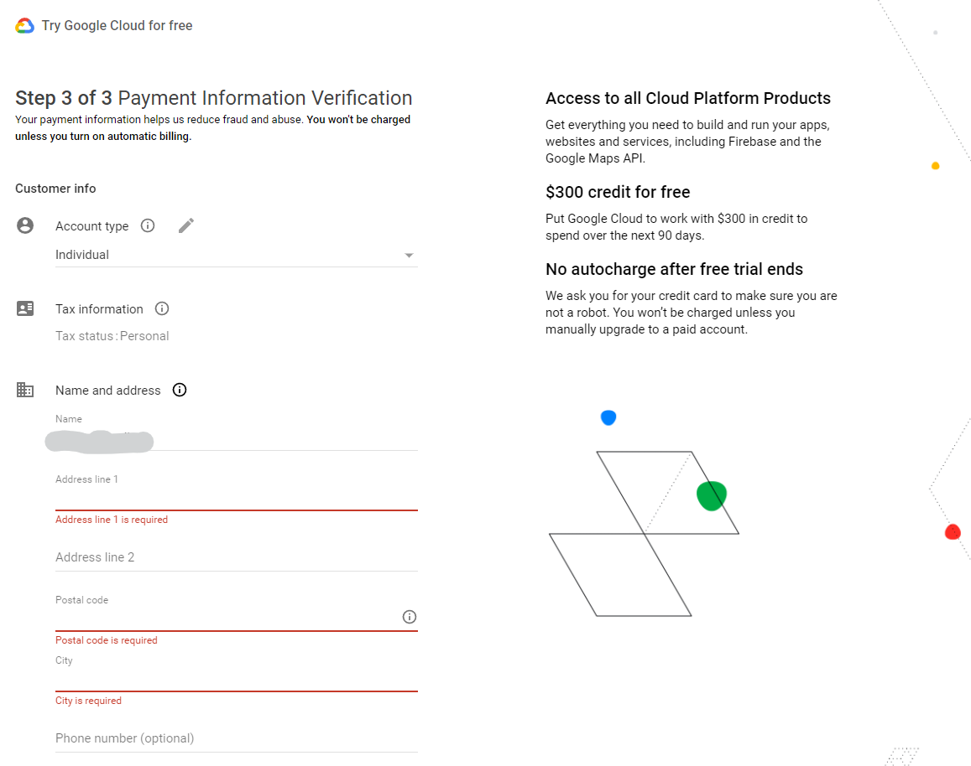

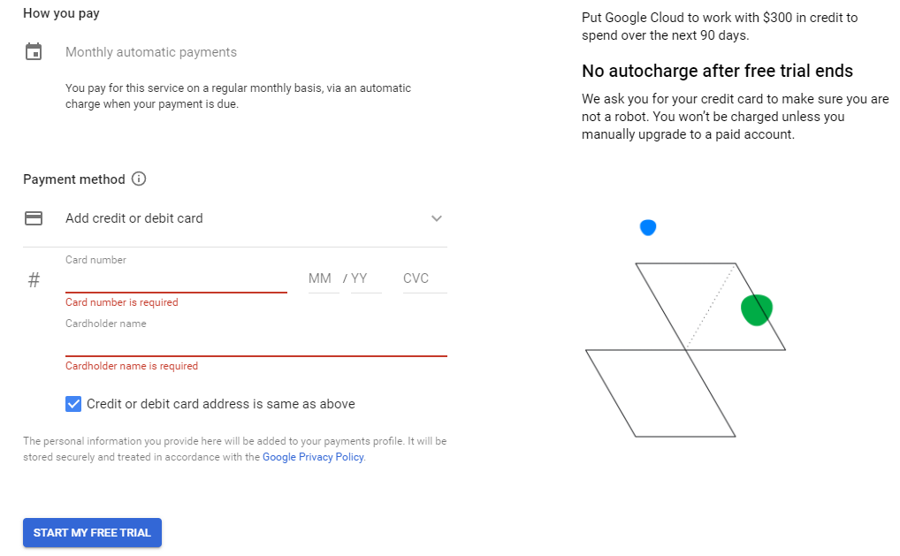

Input all fields + Credit card number => Start my free trial

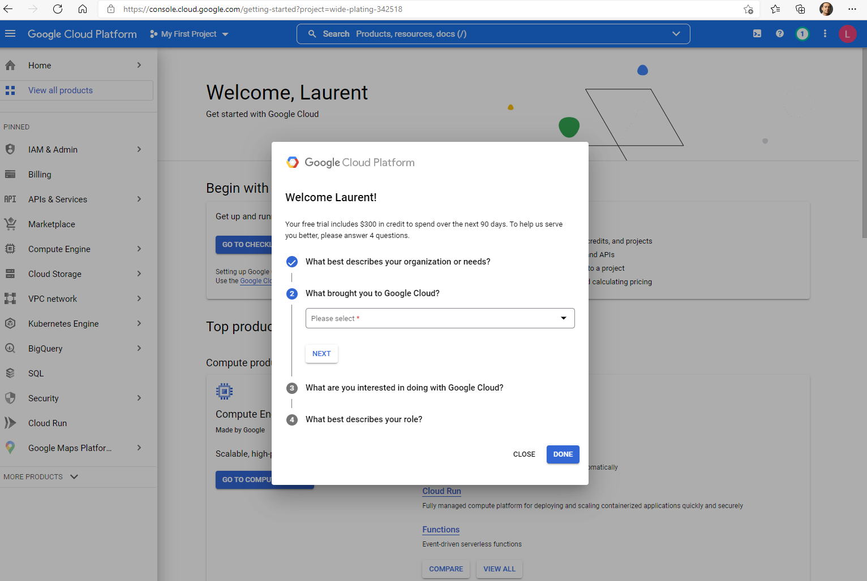

* Done

* Skip for now

Click on Billing in the left menu

* Check your free trial credits

Click on Upgrade to upgrade to a PAID Cloud billing account

* Mandatory to use a GPU
* Your credit remains valid during the trial period

ACTIVATE

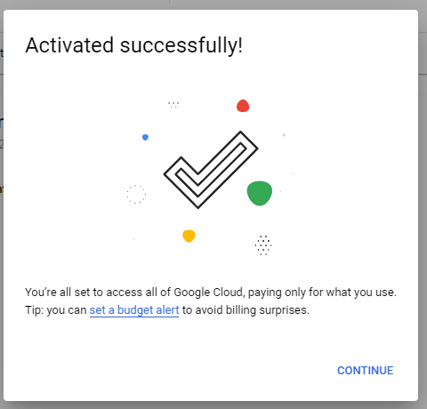

CONTINUE

Click on Billing / Budget & alerts => CREATE BUDGET

Budget Name => Next

Specify the maximum monthly amount you want to spend => NEXT

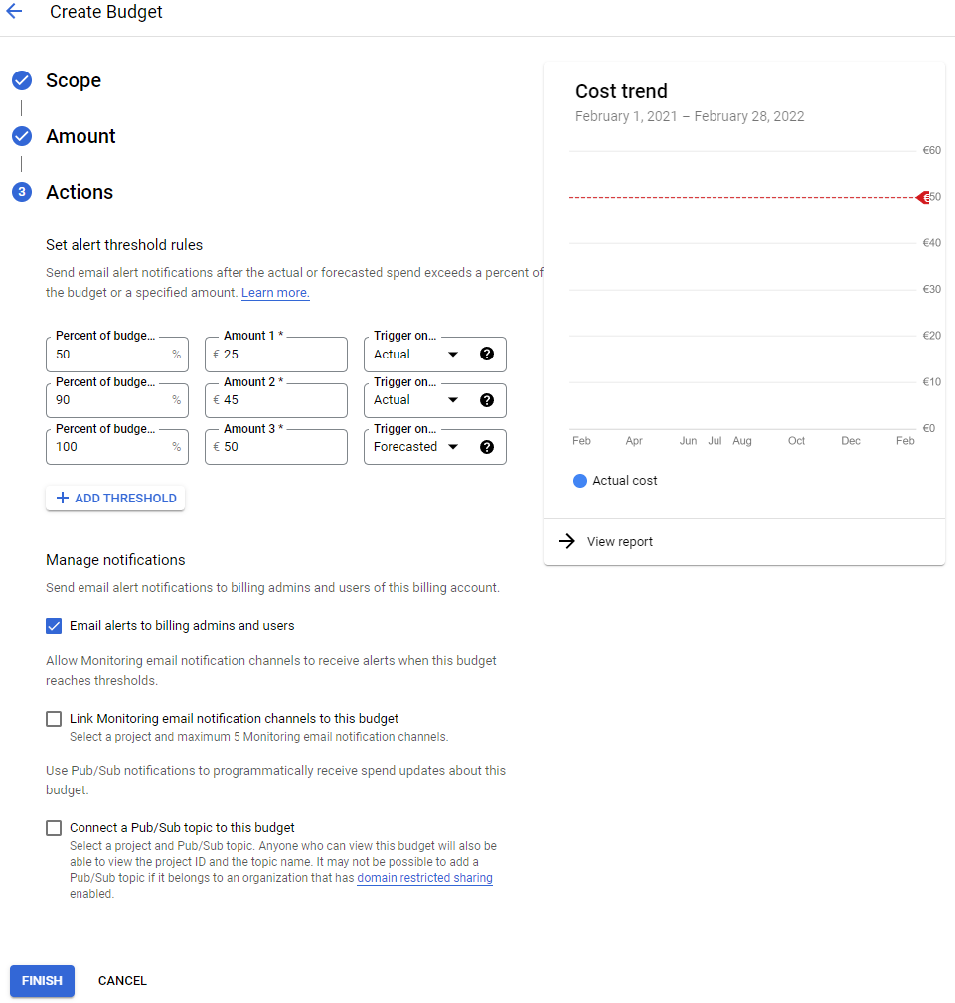

Trigger 100% warning on Forecasted spending

FINISH

* You will receive an email when you actually spent 50%, 90% and when Google Cloud forecasts that your monthly spending may exceed your maximum threshold

Click on APIs & Services / Enabled APIS & services

Check if Compute engine API is enabled => if not ENABLE APIS AND SERVICES

Type « compute » and Enter

Click on Compute Engine API

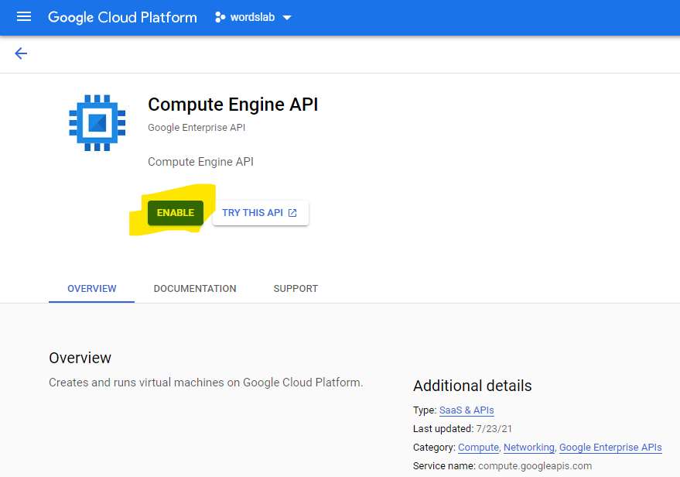

Click on ENABLE

Wait a few seconds …

Go to Home / Dashboard

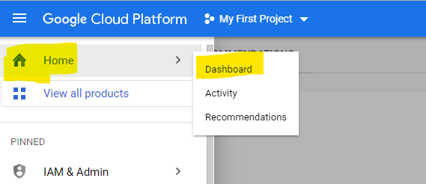

Click on Go to project settings

Choose your project name => SAVE

Click in the menu IAM & Admin => Quotas

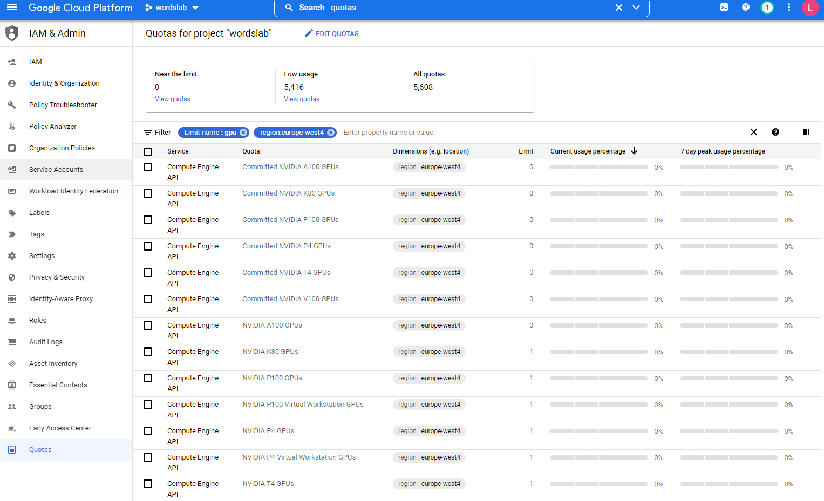

Filter : Limit name:gpu / region:europe-west-4

Check : NVIDIA A100 GPUs / NVIDIA T4 GPUs / Preemptible NVIDIA A100 GPUs / Preemptible NVIDIA T4 GPUs

Click on EDIT QUOTAS

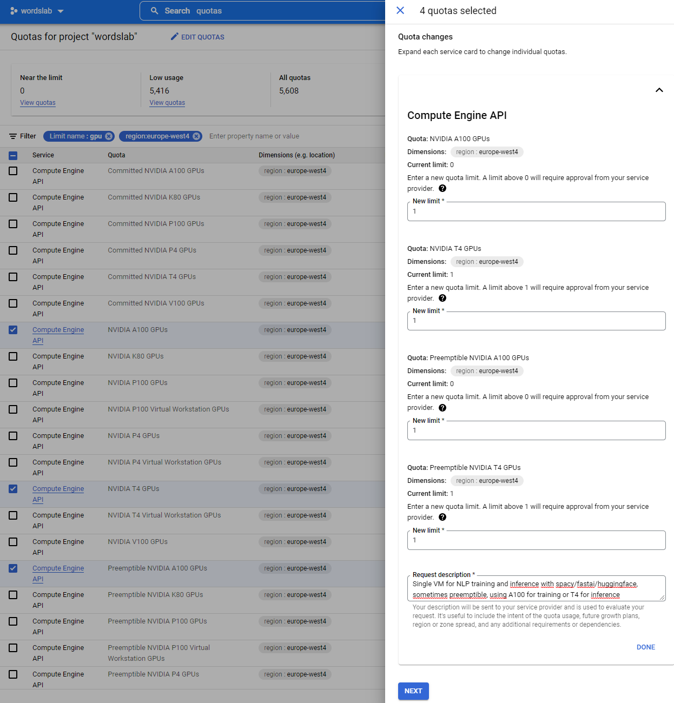

1 limit for all + description => NEXT

Input phone number + SUBMIT REQUEST

Email received

One minute later, request approved

# Gcloud download & install

<https://cloud.google.com/sdk/docs/install>

<https://cloud.google.com/sdk/docs/downloads-versioned-archives>

Download

<https://dl.google.com/dl/cloudsdk/channels/rapid/downloads/google-cloud-sdk-374.0.0-windows-x86_64-bundled-python.zip>

<https://dl.google.com/dl/cloudsdk/channels/rapid/downloads/google-cloud-sdk-374.0.0-linux-x86_64.tar.gz>

<https://dl.google.com/dl/cloudsdk/channels/rapid/downloads/google-cloud-sdk-374.0.0-darwin-x86_64.tar.gz>

Extract the contents of the file to any location on your file system. Preferably, this is your Home folder.

To add the gcloud CLI tools to your path, run the install script from the root of the folder you extracted. Running this script also generates instructions to enable command completion in your bash shell (Linux and macOS only) and enable usage reporting.

./google-cloud-sdk/install.sh

.\google-cloud-sdk\install.bat

To initialize the gcloud CLI, run gcloud init:

./google-cloud-sdk/bin/gcloud init

C:\Users\laure>C:\Users\laure\google-cloud-sdk\google-cloud-sdk\install.bat

Welcome to the Google Cloud CLI!

To help improve the quality of this product, we collect anonymized usage data

and anonymized stacktraces when crashes are encountered; additional information

is available at <https://cloud.google.com/sdk/usage-statistics>. This data is

handled in accordance with our privacy policy

<https://cloud.google.com/terms/cloud-privacy-notice>. You may choose to opt in this

collection now (by choosing 'Y' at the below prompt), or at any time in the

future by running the following command:

gcloud config set disable_usage_reporting false

Do you want to help improve the Google Cloud CLI (y/N)? N

Your current Google Cloud CLI version is: 374.0.0

The latest available version is: 374.0.0

+------------------------------------------------------------------------------------------------------------+

| Components |

+---------------+------------------------------------------------------+--------------------------+----------+

| Status | Name | ID | Size |

+---------------+------------------------------------------------------+--------------------------+----------+

| Not Installed | App Engine Go Extensions | app-engine-go | 4.2 MiB |

| Not Installed | Appctl | appctl | 18.7 MiB |

| Not Installed | Cloud Bigtable Command Line Tool | cbt | 8.4 MiB |

| Not Installed | Cloud Bigtable Emulator | bigtable | 5.9 MiB |

| Not Installed | Cloud Datalab Command Line Tool | datalab | < 1 MiB |

| Not Installed | Cloud Datastore Emulator | cloud-datastore-emulator | 18.4 MiB |

| Not Installed | Cloud Firestore Emulator | cloud-firestore-emulator | 40.5 MiB |

| Not Installed | Cloud Pub/Sub Emulator | pubsub-emulator | 60.7 MiB |

| Not Installed | Cloud SQL Proxy | cloud_sql_proxy | 7.4 MiB |

| Not Installed | Google Container Registry's Docker credential helper | docker-credential-gcr | 1.8 MiB |

| Not Installed | Minikube | minikube | 27.3 MiB |

| Not Installed | Skaffold | skaffold | 18.4 MiB |

| Not Installed | anthos-auth | anthos-auth | 18.1 MiB |

| Not Installed | config-connector | config-connector | 49.8 MiB |

| Not Installed | gcloud Alpha Commands | alpha | < 1 MiB |

| Not Installed | gcloud Beta Commands | beta | < 1 MiB |

| Not Installed | gcloud app Java Extensions | app-engine-java | 51.6 MiB |

| Not Installed | gcloud app PHP Extensions | app-engine-php | 19.1 MiB |

| Not Installed | gcloud app Python Extensions | app-engine-python | 7.8 MiB |

| Not Installed | gcloud app Python Extensions (Extra Libraries) | app-engine-python-extras | 26.4 MiB |

| Not Installed | kubectl | kubectl | < 1 MiB |

| Not Installed | kubectl-oidc | kubectl-oidc | 18.1 MiB |

| Not Installed | pkg | pkg | |

| Installed | BigQuery Command Line Tool | bq | 1.0 MiB |

| Installed | Cloud Storage Command Line Tool | gsutil | 8.1 MiB |

| Installed | Google Cloud CLI Core Libraries | core | 22.3 MiB |

+---------------+------------------------------------------------------+--------------------------+----------+

To install or remove components at your current SDK version [374.0.0], run:

$ gcloud components install COMPONENT_ID

$ gcloud components remove COMPONENT_ID

To update your SDK installation to the latest version [374.0.0], run:

$ gcloud components update

Update %PATH% to include Cloud SDK binaries? (Y/n)? Y

The installer is unable to automatically update your system PATH. Please add

C:\Users\laure\google-cloud-sdk\google-cloud-sdk\bin

to your system PATH to enable easy use of the Cloud SDK Command Line Tools.

For more information on how to get started, please visit:

<https://cloud.google.com/sdk/docs/quickstarts>

C:\Users\laure>cd C:\Users\laure\google-cloud-sdk\google-cloud-sdk\bin

C:\Users\laure\google-cloud-sdk\google-cloud-sdk\bin>gcloud init

Welcome! This command will take you through the configuration of gcloud.

Your current configuration has been set to: [default]

You can skip diagnostics next time by using the following flag:

gcloud init --skip-diagnostics

Network diagnostic detects and fixes local network connection issues.

Checking network connection...done.

Reachability Check passed.

Network diagnostic passed (1/1 checks passed).

You must log in to continue. Would you like to log in (Y/n)? Y

Your browser has been opened to visit:

https://accounts.google.com/o/oauth2/auth?response_type=code&client_id=32555940559.apps.googleusercontent.com&redirect_uri=http%3A%2F%2Flocalhost%3A8085%2F&scope=openid+https%3A%2F%2Fwww.googleapis.com%2Fauth%2Fuserinfo.email+https%3A%2F%2Fwww.googleapis.com%2Fauth%2Fcloud-platform+https%3A%2F%2Fwww.googleapis.com%2Fauth%2Fappengine.admin+https%3A%2F%2Fwww.googleapis.com%2Fauth%2Fcompute+https%3A%2F%2Fwww.googleapis.com%2Fauth%2Faccounts.reauth&state=Ja2kQONS1ehWvQkA0pENc39RI2IIn1&access_type=offline&code_challenge=ZXklu2DOB6NRjFFVWJxUYR_VR8HH3LWtkWum4RbTsJE&code_challenge_method=S256

Select account

Allow

You are logged in as: [xxxxxxxxxxxxxx].

Pick cloud project to use:

[1] xxxx-yyyyyy-342518

[2] Enter a project ID

[3] Create a new project

Please enter numeric choice or text value (must exactly match list item): 1

Your current project has been set to: [xxxx-yyyyyy-342518].

Do you want to configure a default Compute Region and Zone? (Y/n)? Y

Which Google Compute Engine zone would you like to use as project default?

If you do not specify a zone via a command line flag while working with Compute Engine resources, the default is

assumed.

[1] us-east1-b

[2] us-east1-c

…

[14] europe-west4-a

[15] europe-west4-b

[16] europe-west4-c

Please enter numeric choice or text value (must exactly match list item): 14

Your project default Compute Engine zone has been set to [europe-west4-a].

You can change it by running [gcloud config set compute/zone NAME].

Your project default Compute Engine region has been set to [europe-west4].

You can change it by running [gcloud config set compute/region NAME].

Created a default .boto configuration file at [C:\Users\laure\.boto]. See this file and

[https://cloud.google.com/storage/docs/gsutil/commands/config] for more

information about configuring Google Cloud Storage.

Your Google Cloud SDK is configured and ready to use!

* Commands that require authentication will use xxxxxxxxxx by default

* Commands will reference project `xxxxxx-yyyyyyyy-342518` by default

* Compute Engine commands will use region `europe-west4` by default

* Compute Engine commands will use zone `europe-west4-a` by default

Run `gcloud help config` to learn how to change individual settings

This gcloud configuration is called [default]. You can create additional configurations if you work with multiple accounts and/or projects.

Run `gcloud topic configurations` to learn more.

Some things to try next:

* Run `gcloud --help` to see the Cloud Platform services you can interact with. And run `gcloud help COMMAND` to get help on any gcloud command.

* Run `gcloud topic --help` to learn about advanced features of the SDK like arg files and output formatting

* Run `gcloud cheat-sheet` to see a roster of go-to `gcloud` commands.